Dustin Shaffer Mission Viejo, California Dustin.N.Shaffer@gmail.com (949) 505 - 4479
_____________________________________________________________________________

Gameplay Programming Internship

I was introduced to video games at an early age. I played the original Nintendo Entertainment System when I was four years old, and it was love at first sight. It has been my goal to make video games for a living since that first experience. In order to achieve this goal, I have transferred from Saddleback College to UCI for a B.S. in Computer Game Science, and to snatch any opportunity related to my goal.

There are plenty of people in the world who want to make video games for a living, but not very many of them put in the time or the effort to actually create a product. I have contributed hundreds of hours of my personal time to working on game projects, all of which have failed (so far). I have learned from both my experiences and mistakes about team building, communication, and software engineering methods. In these failing projects, I have always been the last survivor - the last one painstakingly working on code or design work for the game; unfortunately, I have also learned that a good game cannot be made by a mere individual.

I currently devote both my collegiate studies and spare time to video games - I'm either making them or playing them at any given moment. I often spend my play time bug-searching when playing popular titles - typically duplication glitches, passing through clipped boundaries, messing with timed events, and finding various methods to make unique graphical glitches. I enjoy finding bugs because it makes me feel like I've outsmarted the programmer, and it helps me to progress with my own programming skills. I expect a high level of quality from the games I play, so whenever I'm programming, I'm forced to parallel my expectations. With the given opportunity, I would spend my time ensuring the quality of a game before its release instead of searching for a pitiful plethora of unfixed bugs afterwards. I hope I can give you a chance to see that I too follow the AAA standard.

Sincerely,
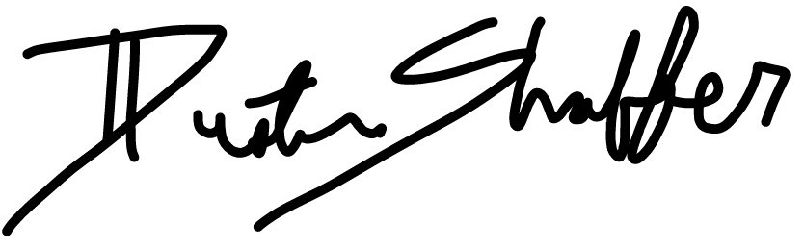

Dustin Shaffer

